Mindfulness Stress Reduction Workshops
For groups, professionals, and corporations.

Mindfulness is being fully in the present moment with acceptance of your experience.

In this workshop, Dr. Edmunds will lead the group through mindfulness exercises that have been proven to reduce stress and improve well-being. These exercises are simple, effective, and easy to practice.

Mindfulness can:
- Improve productivity
- Increase job satisfaction
- Improve workplace relationships
- Increase sleep quality
- Decrease job burn-out
- Help with conflict resolution
- Decrease anxiety

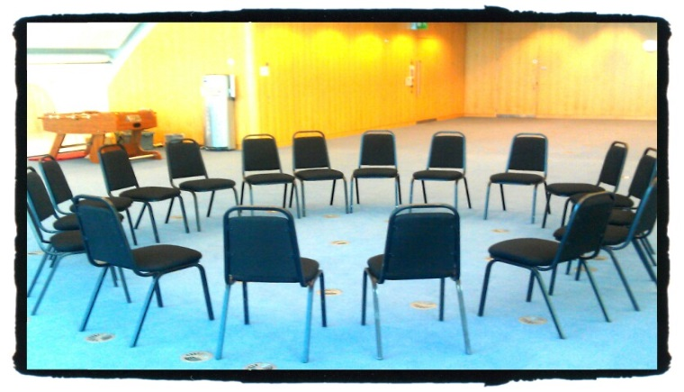
For more information, pricing, and group rates, contact Dr. Edmunds by phone or email below.
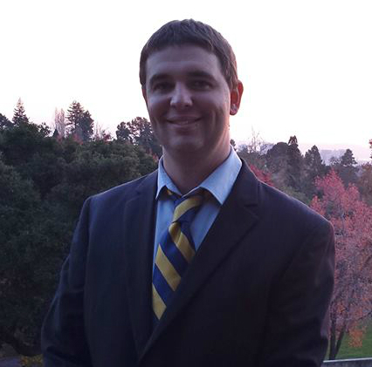
Dr. Edmunds received his doctorate of psychology (Psy.D.) from the California School of Professional Psychology in San Francisco. He has worked in schools, college counseling, and community mental health clinics helping adolescents and adults reduce their stress and live more mindful lives. He has been practicing mindfulness meditation for over 8 years.
Dr. Ellis Edmunds, Psy.D.
PSY27058
510-473-5083
drellisedmunds@gmail.com

